Notes CH- 4 Formatting in MS – Word 2013
Textbook Question
- What Do you mean by Default setting ?
Ans : Any setting that are standard or pre-defined in a software are called Default setting
- What is the Use of Highlighting Text ?
Ans: Highlighting makes the text look different and draws the readers’ attention towards it.
- What is the default font and font size in MS-Word 2013?
Ans: Default font in Word 2013 is Calibri and font size is 11.
- The Text Effect option is available on which tab?
Ans: Text Effect option is available on HOME tab.
- What is keyboard shotcut key to justify align the paragraph?
Ans: The Keyboard shortcut to justify align the paragraph is Ctrl + J

Extra Question
1) Observe the figure given below and answer the following questions:
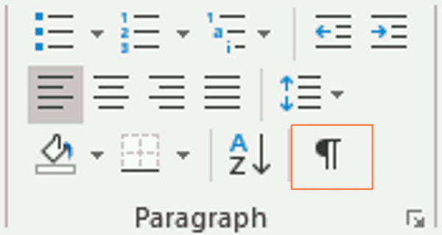
1) Name the tab that has Paragraph group?
Tab that has Paragraph group – ✅ Home tab
2) Which alignment option is selected in the figure?
Alignment option shown – ✅ Centre align
3) What is the keyboard shortcut for this option?
Keyboard shortcut for this option – ✅ Ctrl + E
4) Draw the option whose keyboard shortcut is Ctrl + R?
Draw the option for Ctrl + R – ✅ Right Align icon

2) Write the steps to line spacing in paragraph in MS Word?
Ans : Steps for line spacing in paragraph: Select the paragraph → Go to Home tab → Paragraph group →Click Line &amp; Paragraph Spacing option → Choose spacing.

3) Write the steps for printing a document in MS Word?
Steps to Print a Document in MS Word:
- Open the document you want to print.
- Click on the File tab (at the top-left corner).
- From the menu, select Print.
- A Print dialog box (or print preview) will appear.
- Choose the Printer you want to use.
- Select the number of copies you want to print.
- Click on the Print button.

